The brightest pages of my summer dairy
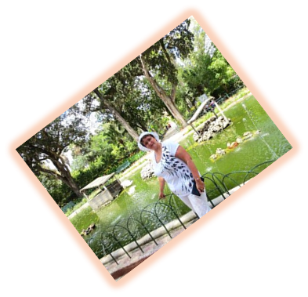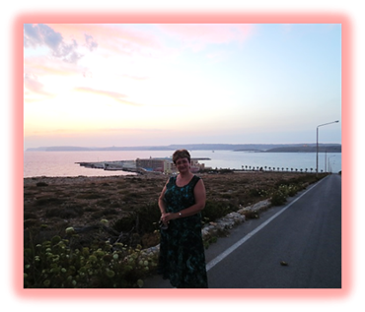
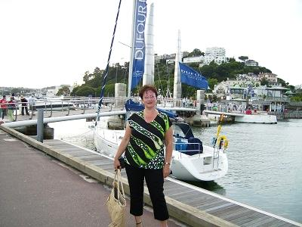

Автор: Захарьина Ольга Валерьевна,
учитель английского языка высшей категории

Школа: МБОУ «Общеобразовательный лицей №17 »
Населенный пункт, регион: г. Северодвинск
Архангельской обл.

Электронный адрес автора работы: zakholga2005@yandex.ru

Many people live a very busy life. So do I. Sometimes I manage extraordinary feats of organization and do more than one thing at the same time. But being a teacher has an undeniable advantage - long summer vacation.
So, I can put up with all the stress during the school year because I anticipate having my long summer holidays. And they usually don’t fail my expectations.
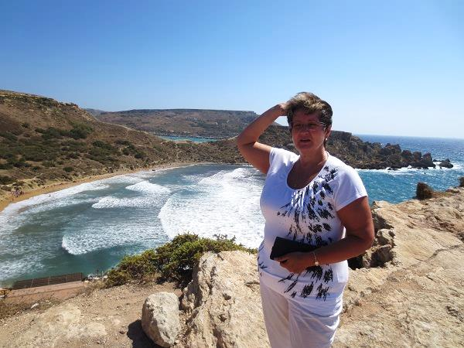
Every summer I take groups of schoolchildren to summer schools abroad. Last summer was not an exception. I spent three weeks on a wonderful island of Malta, three weeks in England and had a month of complete relaxation in my parents’ native town of Balakhna, Nizhny Novgorod.
It was my second trip to Malta but I loved this unusual island with its peculiar nature even more than when I was there three years ago.
Though some think it’s strange for a southern country to have such scare vegetation I find this stony ancient beauty absolutely amazing.
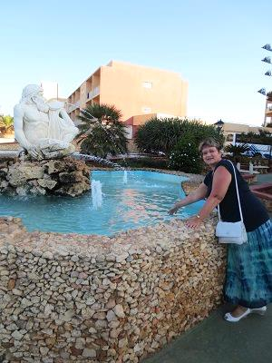
As always we stayed at The Paradise Bay Resort Hotel which is very spacious and comfortable.
It’s great that it is situated rather far from all the major cities. It creates a special insular atmosphere. It’s thrilling to view both Gozo and Camino picturesque sister islands from your hotel window. Each time we returned to the hotel from a walking tour we couldn’t help admiring the stunning view of our hotel.
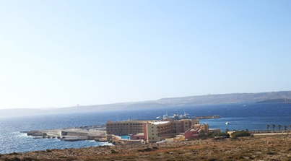
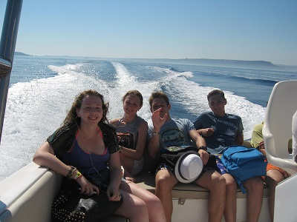
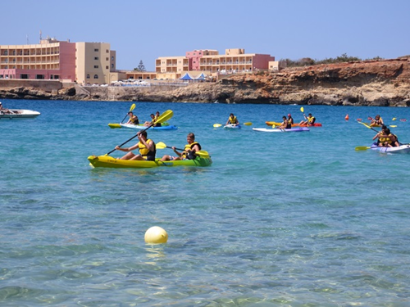
Both the children and the leaders enjoyed the activities organized by the school. We never got bored or tired of swimming, boating, kayaking, making bonfires, doing sports.

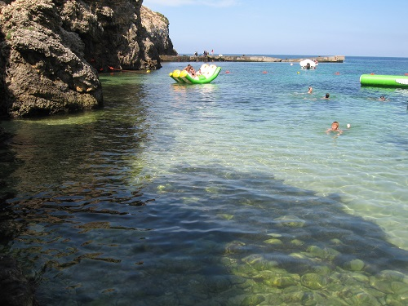
A trip to fun park Popeye village was really an unforgettable experience with an out-door pool, water slides, shows, dancing, singing, film-making. We all felt real stars taking part in the movie organized by the members of the staff, who were dressed up as Popeye and Olive.
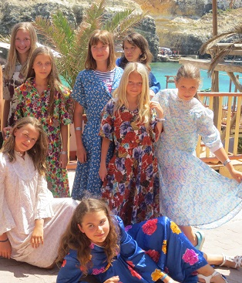
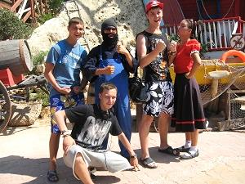

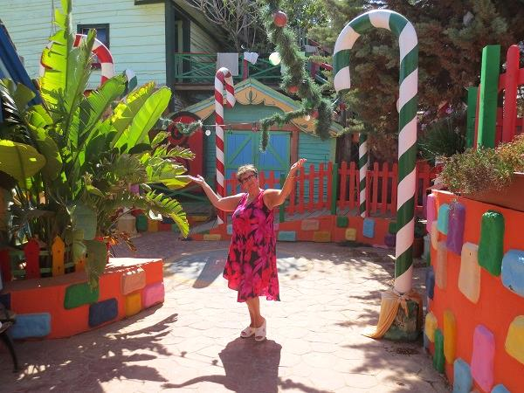
We were surprised to meet summer plants and Christmas decorations in the same place.

Another bright memory was our visit to Mdina...
Imagine... you see a city surrounded by thick defense walls built upon a hill. You walk through a gate...and the noise disappears. You are in a jewel of medieval town. Mdina is a stunning city.
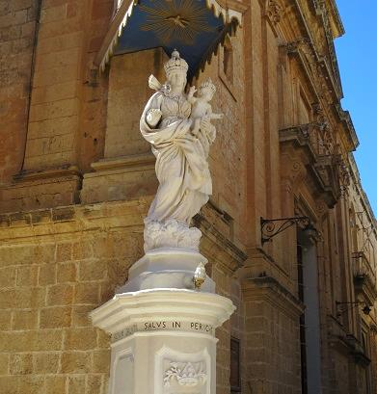
As soon as you put a step on its pavement it seems to you as if a knight should appear round the corner in his sparkling amour. Sometimes I could even hear the clattering of his sword. Mdina is rightfully called the Silent City since it inspires tranquility at any time of the day or night. Walking around the limestone-built, walled city, with its iron gratings, hanging lanterns, and narrow passageways, was like going back in time. It was a pleasure just to be there. Only residents can have cars inside the walls, so that meant there was little traffic, too. When we explored the quaint alleys, narrow streets, ancient buildings and magnificent far reaching views form the high bastion walls we felt ourselves an integral part of that mysterious place.
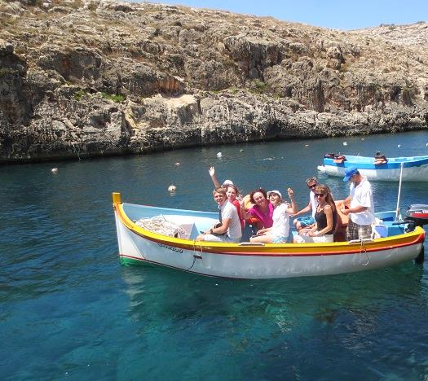
But what we enjoyed most were our trips to the Blue Lagoon and Blue Grotto.

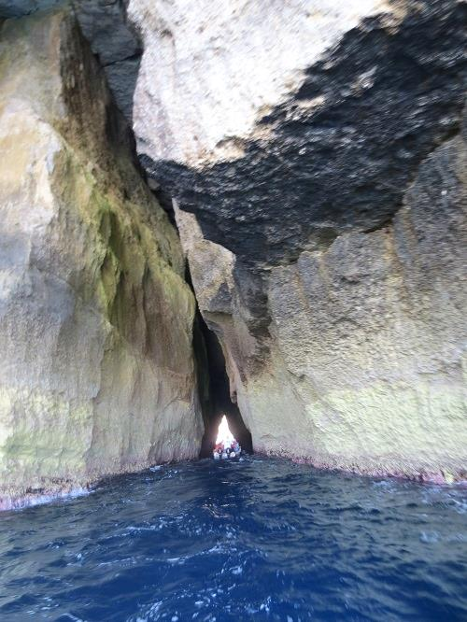
The boat ride in Blue Grotto lasted around 30 minutes. The water was clear and so deep! The sunlight on the water really enhanced the beauty of the place. The water and the caves were amazing. Sometimes I was even scared – so deep and horrifying the caves seemed!
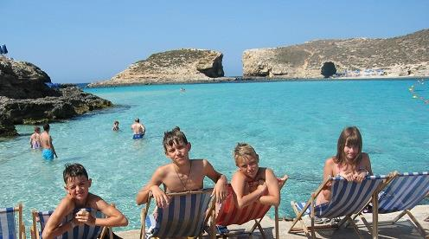
As for the Blue Lagoon, it was real fun! The view was great and you could relax on the sun beds. The sea was crystal clear and incredibly blue, and the sand in the water was white. Both swimming and pillow-riding was great experience!
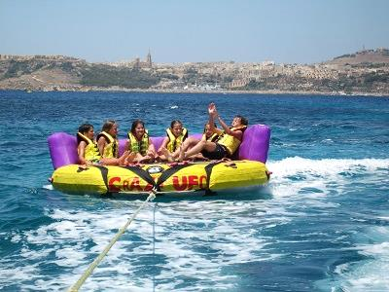
A great feeling of being a part of a team and sharing the excitement with the group also added to the pleasure of our stay in Malta.
We made new friends, were thoroughly relaxed and soaked in the sun and the sea air. I am sure it will give me vitality and energy to keep going through the winter.

… After Malta I flew to London with a group of schoolchildren from my town. Our destination was Torquay.
It was a wonderful experience as we had to travel on our own and try the National Express service. The students were impressed by the quality of public transport in England. All the coaches were on time and it was no trouble to travel from Heathrow to Torquay Limington coach station where we were met by the host families.

Torquay is a small beautiful town in the south-west of
England. It is often referred to as ‘The English Riviera’ and we can understand why.
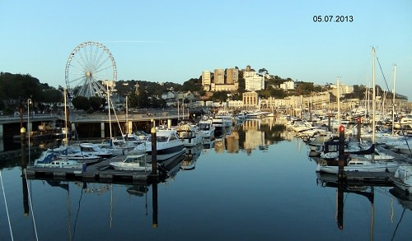
It is very cozy with a relaxed, friendly atmosphere and a stunning coastline. It has a lively harbour, palm tree lined promenades, gardens and many countryside sights.
We enjoyed our visit to the Babacombe Model Village which is famous for its miniature landscaped gardens.
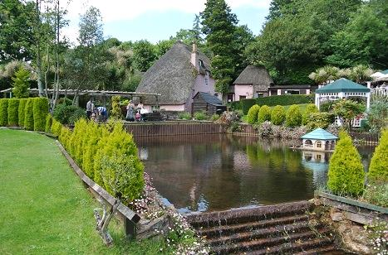
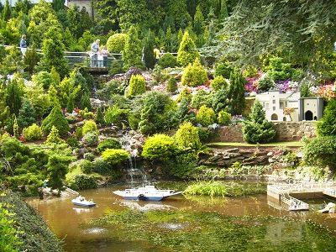
It’s amazing how everything is organized and kept there. You can experience the feeling of being Gulliver in the Land of Lilliput though unlike Jonathan Swift’s character your experience is that of joy and happiness. You see a steamer hurrying along the river, you watch a soccer game at the stadium; you can even hear a dragoon casting out fire.
But it was the English countryside that we admired most. While travelling about England we could witness that it is rightfully compared to a well-kept garden.

We could gaze across the countryside, noticing wide open landscapes, rushing rivers and different coloured patches which showed the crops, and in the distance a picture postcard village or a town with its groups of huts clustered together. We found such views absolutely idyllic especially when we could see some sheep eating the grass or resting peacefully.
We were lucky as the weather was not typically English. It was hot and sunny during all our stay there.
So, besides visiting the major places of interest we enjoyed sunbathing, swimmy and water spots. The water in the sea was pretty chilly but it was a challenging experience especially for our children from the north of Russia.

…. The last month of my summer holidays I spent with my family in a small Russian town of Balakhna. Although my staying there was not so impressive I absolutely enjoyed it.
It was a welcome rest. Everybody needs complete solitude sometimes when you can take some books and catch up on your reading.
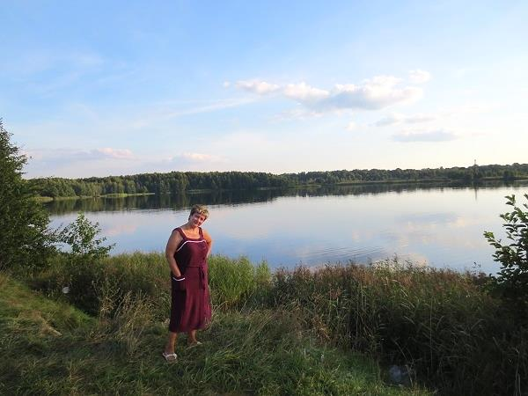
And no one can deny the fact that the Russian nature is full of charm and peace. So, I had a profitable and refreshing time there, as well.

But summer months go so quickly...
I came home greatly refreshed and wonderfully tanned. I am sure that the bright pages of my summer diary will see me through long winter months.

Все фотографии из личного архива автора.
Фото несовершеннолетних публикуются с согласия родителей.

